The Planner Section

Student Reference Guide

# Overview

Use Planner tools such as goals, to-do lists and tasks to create personalized plans of action that help you achieve your goals. To access the Planner overview page, go to Planner > Planner Home. From the Planner overview page, you can quickly access overdue tasks, a calendar of past and upcoming events, and recently completed tasks and to-dos.

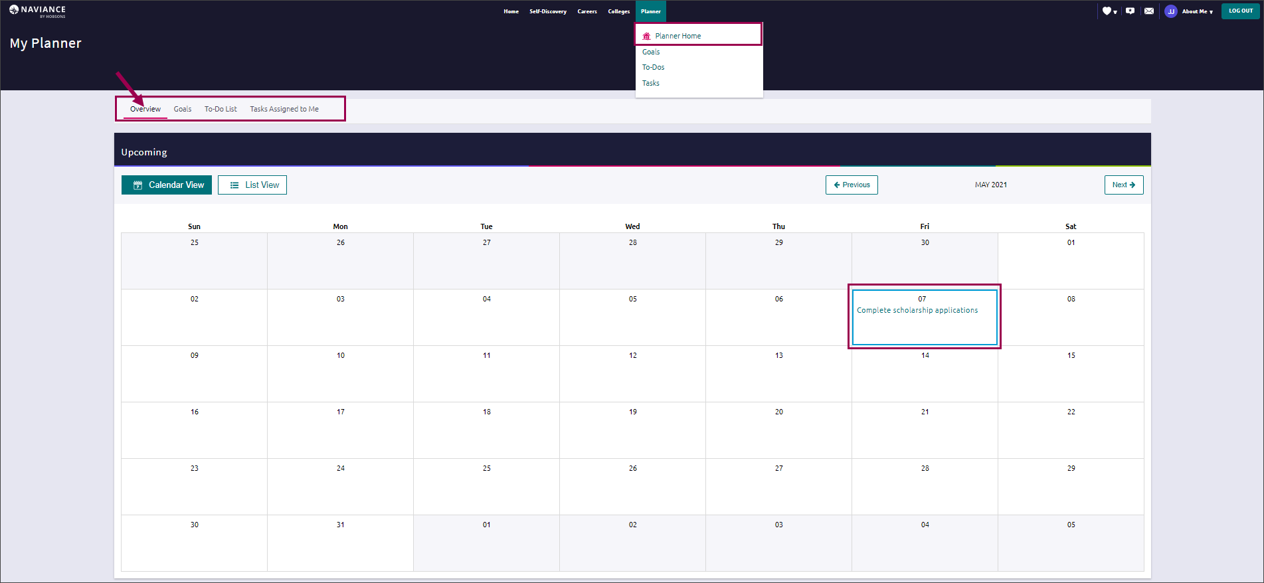

# Goals

## Adding a Goal

A set of goal categories will be visible when you navigate to Planner > Goals.

* 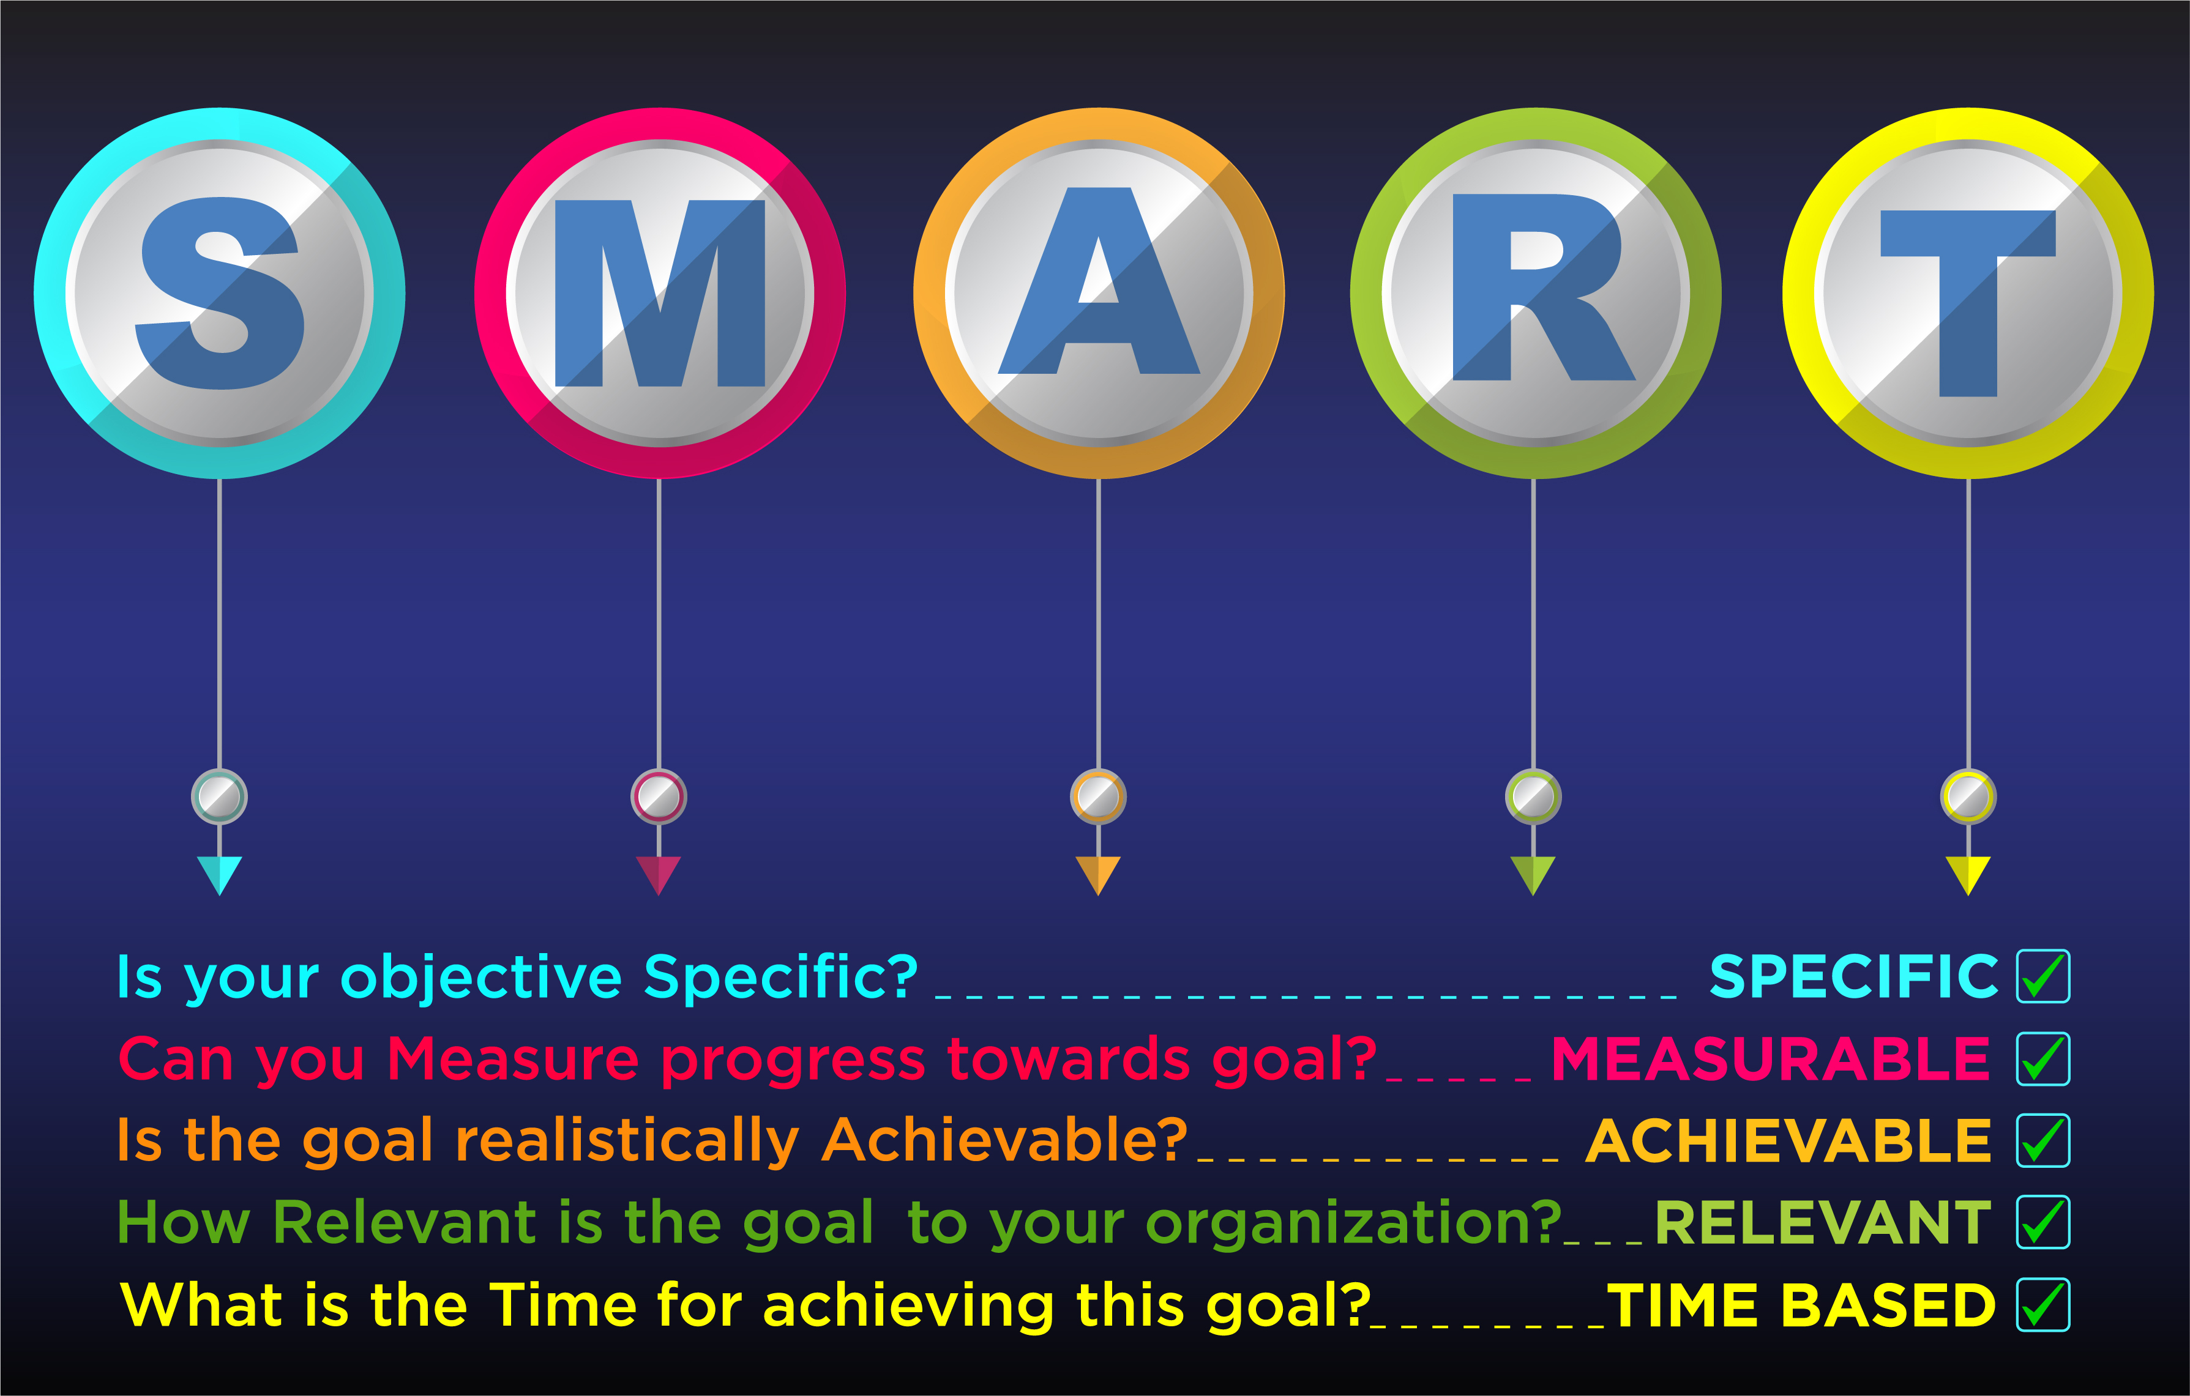What is a goal? A goal is an aim or a desired result. SMART goals are a way of writing goals to make them more achievable.

1. Select a goal category and click the + sign below the category to get started.

### Alternatively, hit the Pink (+) button to select a goal category)

1. Fill in the fields to create your SMART goal.
2. Click Add.
3. Once you have added your goal, you can add comments and next steps to help you achieve your goal.

The goal is now accessible from the Goal Category.

1. Open the goal to mark it as done, edit the goal, or remove it. Not all goals can be marked done but, instead, are completed once a file is uploaded or some other criteria is met.

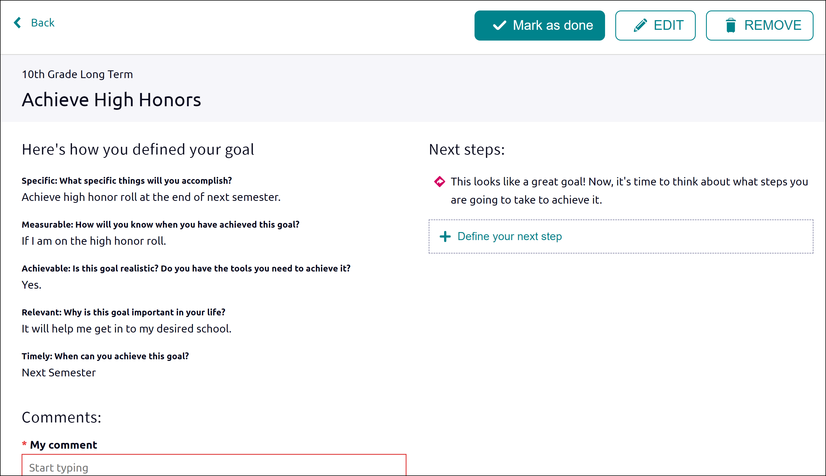

# To-Do List

## Adding to the To-Do List

Use the To-Do List to add or view action items that you need to complete by going to Planner > ToDos.

1. Click the pink + (plus) button to add a To-Do.
2. Enter the information about the To-Do, use the drop-down to associate a goal or task with the To-Do, select a priority, and add an optional due date.
3. Click Add.

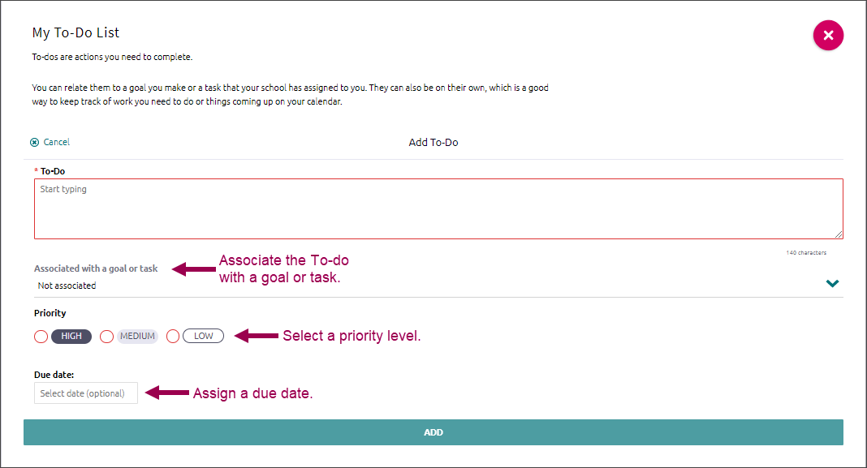

## Viewing the To-Do List

View the To-Do List using sorting and filtering tools.

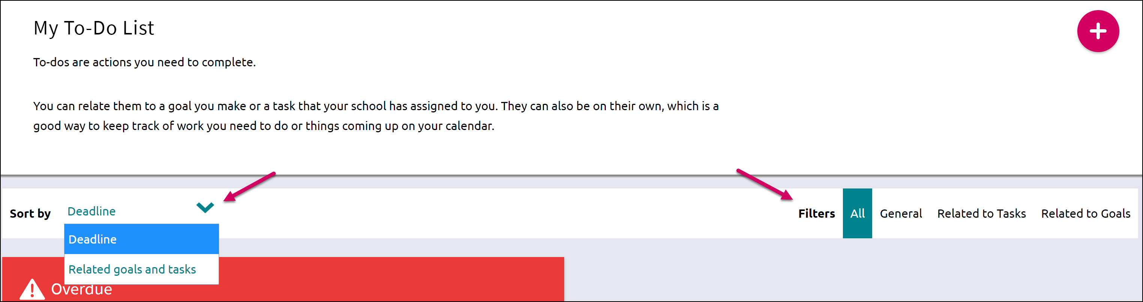

# Tasks Assigned to Me

## Overview

This section includes tasks that have been assigned to you by your school. They may be tasks that are required for graduation, so be sure to review the listed tasks.

The Tasks Assigned to Me page is broken down into four content cards. They include:

* Tasks you Need to Work On: Upcoming tasks that are either labeled as graduation or required tasks.
* Tasks you’ve Completed: Tasks that you have finished and marked completed.
* Overdue: Tasks in which the due date has already passed. These tasks require immediate attention.
* Tasks for Future Grades: Tasks that you do not need to worry about now, but that will be upcoming as you move to the next grade level.

## Viewing Tasks

Click once on a task to open it and take an action such as:

* Raise Hand: Ask a question of the counselor or teacher that assigned the task.
* Add a Comment: Type and add a comment. Comments can be viewed by associated teachers and counselors, as well as parents.
* Attach Files: Add a file that relates to the task.
* Create Connected To-Dos: Create a To-Do item that will be added to your To-Do list but associated with the task.
* Mark as Done: Depending on the way that a task has been assigned by your school, you may have to manually mark the task as completed. This button will be visible next to Raise Hand if it is activated.

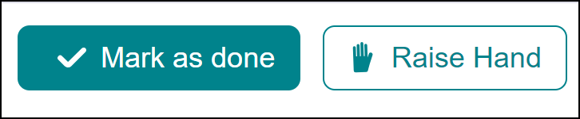

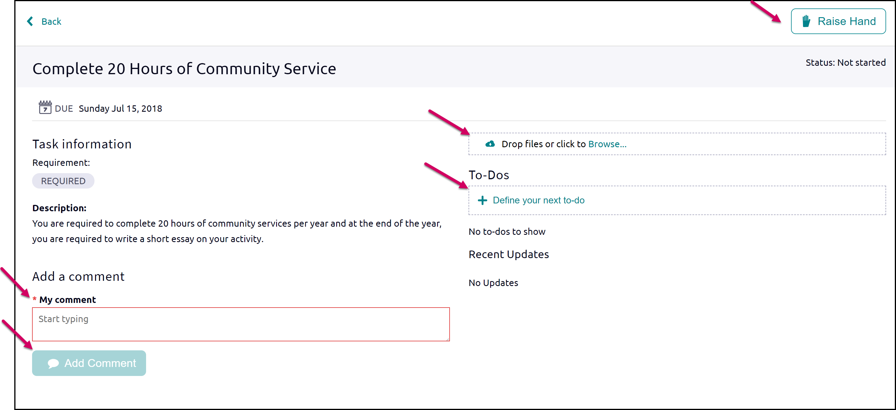

In some instances, tasks will be shared with multiple students. If that is the case, you will see a note on the page above that reads as shown here:

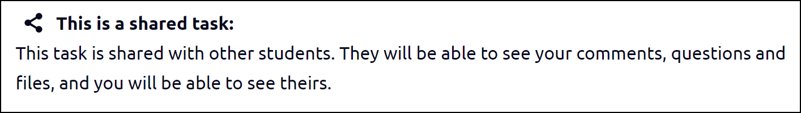

When there is shared activity, you will also be able to use a filter to find all, your own, or other’s activity:

